### **Exploration of Population Dynamics of Swedish Wolves**

### **Authors:**

### **Nirbhay Bondili**, **Emily Nikiforuk**

### **Introduction**

It is well known that wolves group together into packs - not only are these social units, but reproductive units as well. Typically, each wolf pack has one reproductive event, resulting in one litter of pups. Note that there may be exceptions to this reproductive style, as some wolves will function without a pack.

This project aims to apply stochastic birth-death models to an isolated wolf population in Sweden, from 1980-2001. Prior to 1991, this wolf population was relatively stable, and it is hypothesized that the population suffered from inbreeding depression due to the lack of new genes entering the population. This changed in 1991 with the migration of a Russian wolf, bringing new genes and sparking an increase in population size. This is an example of demographic stochasticity - variation resulting from the behavior of individuals within the population. Stochasticity has a stronger effect in small populations, such as those at risk of extinction. We will analyze the data over the time period from 1980-2001 to see how the population size changes, and to predict the mean time to extinction.

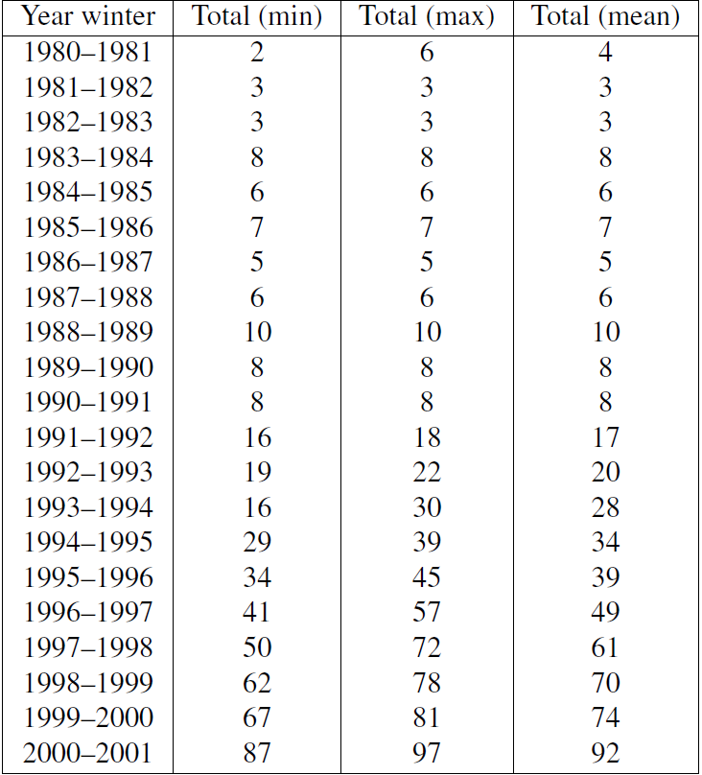

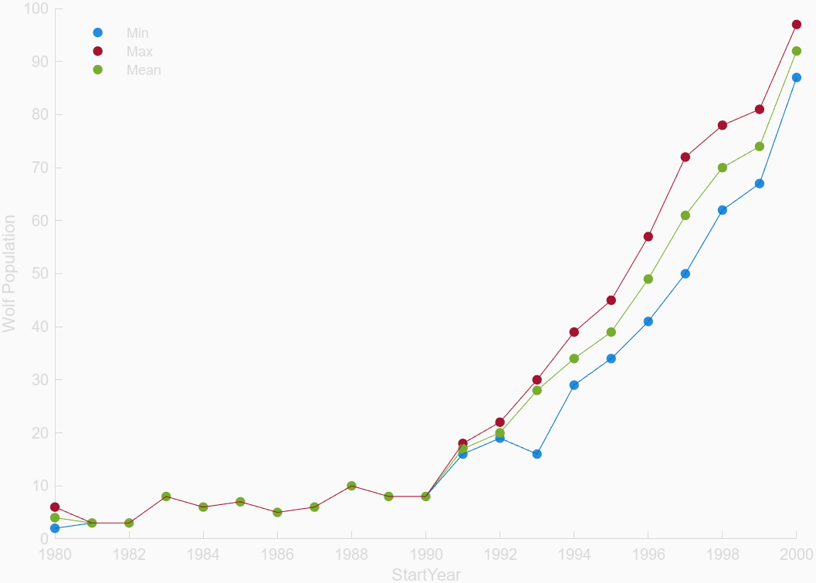

### **Formulation of the mathematical model**

Assumptions of the models:

* One reproductive couple per pack
* One litter per year per pack
* Average litter = 5 pups
* Reproduction attempts are constant
* 50-50 distribution gender
* Average pack = 10 wolves
* Average age =12

Discrete Time Model:

* Parameters:
  + r = growth factor
  + Pn = population size
* Pn+1= Pn + 5(1-d) → Pn+1= Pn + 5r
  + d = 0.9, r = 0.1
* Pn+1 = Pn(1 + r)
  + r = 0.18

Stochastic Model

* Parameters used
  + b = birth date
  + d = death rate
  + n(t) = population size at time t
* For n individuals
  + Pr(1 birth in [t, t+τ]) =nbτ + o(τ)
  + Pr(1 death in [t, t+τ]) = ndτ + o(τ)
  + Pr(no change in [t, t+τ]) = 1 - n(b+d)τ + o(τ)
* Treating each birth as a Poisson process
  + The probability of a birth occurring in the time interval [t, t+τ] is proportional to τ
  + o(τ) = probability of more than 1 event occurring during the time period τ
* Rearrange into a differential equation:
  + pn(t + τ ) = (n − 1) bτ pn−1(t) + (n + 1) dτ pn+1(t) + (1 − nτ (b + d)) pn(t) + o(τ ),
  + Take solution as τ → 0
  + dpn/dt = (n − 1) b pn−1 + (n + 1) d pn+1 − (b + d) n pn
* Moments and variance:
  + M1(t) = n0ebt
  + M2(t) = 2bM2 + bM1
  + var(N(t)) =(n0 (b + d)/r) * ert * (ert − 1)

### **Solution to the problem**

In the first model (Simple Discrete Time Difference) for a time period 1980 to 1990 the model was solved by specifying time units and solving to obtain the simple difference equation. This equation was used to then get data for a time tn+1 using the value of n. The data provided was plotted for the model output for Pn+1 vs tn+1.

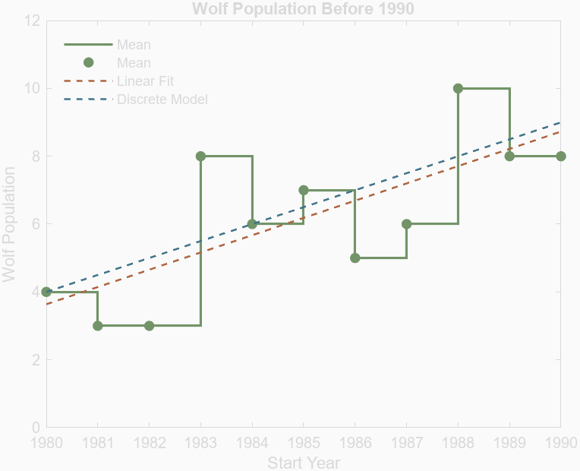

For the time period 1990 to 2000 a time discrete recursive function was used. The fits given by python closely match an exponential function so a recursive model was used. As the mean was looked at and the difference of the births and deaths of the population was used as the growth factor. The output for tn+1 was given using the model and the given values for n.

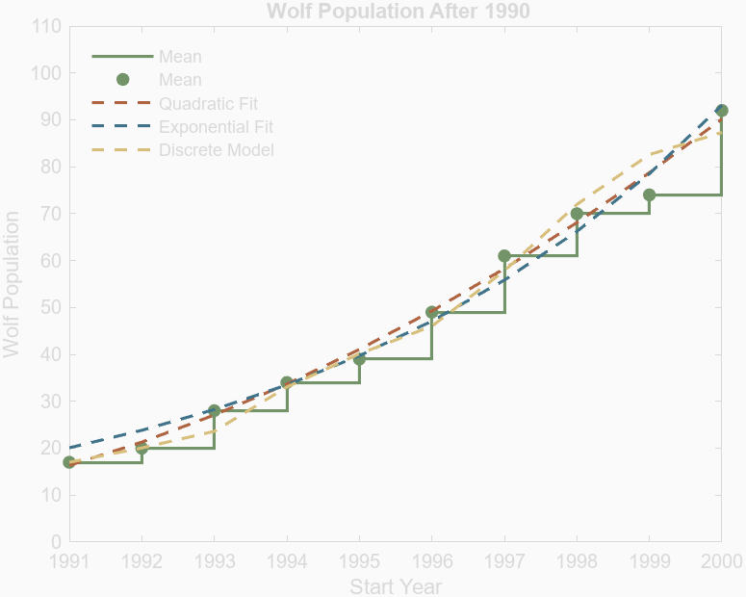

For the stochastic part of the project, explicit stochastic models could be not used as only the means of the population was used in the analysis. Due to this, stochastic behavior was simulated in matlab by using the given data and obtaining a value for tn+1 based on pn. Arbitrary values of birth and deaths were set for the two time periods, they could be any number between 0 and 1 as long as the difference matched the parameters given in the models. Using a built in random number generator in matlab, values between 0 and 1 were assigned to each n of the population. If the random value was below the birth or death rates assigned then the action happened to the n. This process was simulated 999 times to obtain the graphs below. (See Appendix for code)

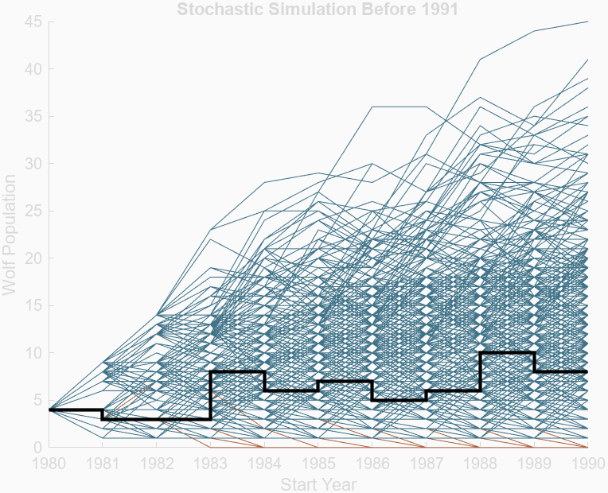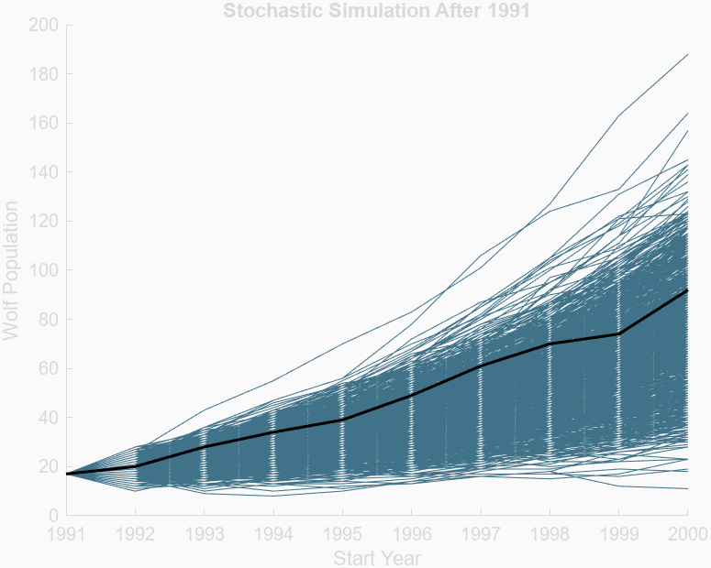

### **Interpretation of results**

Using the models and plots the questions assigned in the project were answered as follows. The birth rate for the population before 1990 is approximated to be about 5 births per pack. The death rate due to age is neglected as the wolves that start the population are young but assume a survival rate of 10 percent for the newborn pups. In the stochastic simulation a birth rate of 0.2 and death rate of 0.1 was used. For the population after 1990 the birth rate and death rates cannot be explicitly calculated as mean population was used. The growth rate which is the difference between the birth and death rates was found to be r = 0.18, for purposes of stochastic simulation a birth rate of 0.5 and death rate of 0.32 were used. From the stochastic simulations a mean time to extinction of 14 years was found. The variance of the populations before and after 1990 were plotted. And before 1990 the variance was not too high but after 1990 it starts to rise exponentially.

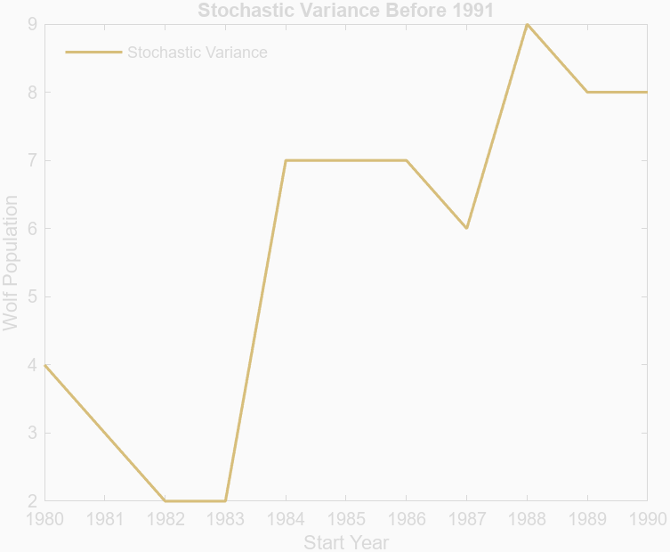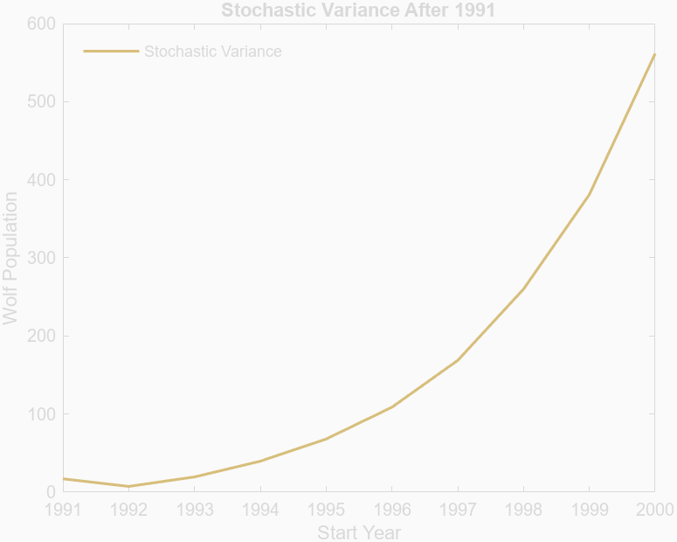

### **Critique of the model**

The models do an adequate job of describing the dynamics of this specific population. In future attempts the project could be expanded by including an analysis for the minimum viable population required to not go extinct. This would involve extrapolating the stochastic simulations to longer time periods. The models could not account for genetic diversity as no data for DNA heterozygosity was included to see what effects the Russian wolf had on the population. Both models forced the entire population into pack divisions, in the real world there would be many cases of lone wolves who do not join packs and therefore can never even have the chance to be considered part of the birthing process. The discrete models were limited in their analysis as growth rates and not specific birth and death rates were used for the population. The stochastic simulations needed many assumptions to be considered a viable approach. Arbitrary values were used for the birth and death rates in the simulations.

### **Appendix**

Code:

function Extinction_Project

% ID :Nirbhay Bondili

% Solution to Project 2.7

% Calculates Birth and Death Rates prior to and after 1991

% Calculates Mean time to extinction

% Calculates mean and variance in population size as function to time before and after 1991

% Assumptions

% A mother wolf can only have one litter per year, and pups are always born in the spring

% Only One litter per pack as only alpha couple breed

% Average of 5 pups per litter

% Assume equal distribution between females and males

% Avergae pack of 10 wolfs, Assume pack splitting once pack > 20

% Average age of wolf = 12 years

% Inital population is mature (>2 years of age)

% According to report approx 0.25 birth rate from 1991 - 2001

% Heteroygosity Rate = 0.54

% colors

dill = [114/255,148/255,104/255]; % Green

peacock = [64/255,115/255,137/255]; % Blue

trumpet = [215/255,190/255,123/255]; % Yellow

earth_jub = [175/255,99/255,65/255]; % Red

off_white = [250/255,250/255,250/255]; % Off White

for i = 4:10

clf(i)

end

% --------------------------------

% Initial plot for picture of entire dataset

pop_dat = readtable("Extinction Data.xlsx");

% PLot 1

figure(1)

scatter(pop_dat, "StartYear", ["Total_min", "Total_max", "Total_mean"], "filled")

hold on

plot(pop_dat.StartYear, pop_dat.Total_mean, 'color', dill);

plot(pop_dat.StartYear, pop_dat.Total_min, 'color', peacock);

plot(pop_dat.StartYear, pop_dat.Total_max, 'color', earth_jub);

legend('Min', 'Max','Mean', 'Location','northwest')

legend('boxoff')

ylabel("Wolf Population")

set(gca, 'Color', off_white)

set(gcf, 'Color', off_white)

hold off

% --------------------------------

% Before 1990 with deterministic model

pop_dat_pre = pop_dat(1:11, :);

% Fit of data using polyfit

fit_1 = fit(pop_dat_pre.StartYear, pop_dat_pre.Total_mean, 'poly1');

% Personal made model = P(n+1) = P(n) + 5*(1-d) , where d = pups rate of death

start_wolf = 4;

r1 = 0.10;

wolf_pop = zeros(height(pop_dat_pre), 1);

wolf_pop(1) = start_wolf;

function pn = pop_n(~)

for i = 2:height(pop_dat_pre)

wolf_pop(i) = wolf_pop(i-1) + 5 * r1*ceil(wolf_pop(i-1)/10);

pn = wolf_pop;

end

end

% Plot 2

figure(2)

stairs(pop_dat_pre.StartYear, pop_dat_pre.Total_mean, 'color', dill, 'LineWidth', 1.5);

hold on

scatter(pop_dat_pre.StartYear, pop_dat_pre.Total_mean, [], 'MarkerFaceColor', dill, 'MarkerEdgeColor', dill);

plot(pop_dat_pre.StartYear, fit_1(pop_dat_pre.StartYear),'--', 'color', earth_jub, 'LineWidth', 1.2);

plot(pop_dat_pre.StartYear, pop_n(pop_dat_pre.Total_mean),'--', 'color', peacock, 'LineWidth', 1.2);

legend('Mean', 'Mean','Linear Fit', 'Discrete Model', 'Location','northwest');

legend('boxoff')

xlabel('Start Year');

ylabel('Wolf Population');

title('Wolf Population Before 1990');

ylim([0, 12]);

set(gca, 'Color', off_white)

set(gcf, 'Color', off_white)

hold off

% --------------------------------

% After 1990 with deterministic model

pop_dat_post = pop_dat(12:21, :);

% Fit of data using ployfit

fit_2 = fit(pop_dat_post.StartYear, pop_dat_post.Total_mean, 'poly2');

fit_3 = fit(pop_dat_post.StartYear, pop_dat_post.Total_mean, 'exp1');

% Personal Discrete model

pn1 = [17,20,28,34,39,49,61,70,74];

pn2 = zeros(length(pn1), 1);

r2=0.18;

pn2(1)=17;

function pnq = pop_nq(~)

for i = 1:length(pn1)

pn2(i+1) = pn1(i)*(1+r2);

pnq = pn2;

end

end

pn3 = pop_nq(pn1);

% Plot 3

figure(3)

stairs(pop_dat_post.StartYear, pop_dat_post.Total_mean, 'color', dill, 'LineWidth', 1.5);

hold on

scatter(pop_dat_post.StartYear, pop_dat_post.Total_mean, [], 'MarkerFaceColor', dill, 'MarkerEdgeColor', dill);

plot(pop_dat_post.StartYear, fit_2(pop_dat_post.StartYear),'--', 'color', earth_jub, 'LineWidth', 1.5);

plot(pop_dat_post.StartYear, fit_3(pop_dat_post.StartYear),'--', 'color', peacock, 'LineWidth', 1.5);

plot(pop_dat_post.StartYear,pn3,'--', 'color', trumpet, 'LineWidth', 1.5);

legend('Mean', 'Mean', 'Quadratic Fit', 'Exponential Fit','Discrete Model ','Location','northwest');

legend('boxoff')

xlabel('Start Year');

ylabel('Wolf Population');

title(' Wolf Population After 1990');

ylim([0, 110]);

set(gca, 'Color', off_white)

set(gcf, 'Color', off_white)

hold off

% --------------------------------

% Stochastic model

% Parameters

int_pop1 = 4; % Initial population size

int_pop2 = 17; % Initial population size

num_sim = 999; % Number of simulations

count = 0; % Number of extinctions

ext_date = []; %year at which extinction accoured, will be filled in later

% Birth and death rates before and after 1991

% we know r1 = 0.1 & r2 = 0.18

b1 = 0.2;

d1 = 0.1;

b2 = 0.5;

d2 = 0.32;

% Time Periods

t1 = 10;

t2 = 9;

t3 = 20;

pop_pre_91 = NaN(num_sim, t1);

pop_post_91 = NaN(num_sim, t2);

pop_extra = NaN(num_sim, t3);

for sim = 1:num_sim

population1 = int_pop1;

population2 = int_pop2;

population3 = int_pop1;

% Model before 1991

for year = 1:t1

if population1 <= 0

population1 = 0;

else

births = 5*sum(rand(ceil(population1/10), 1) < b1);

deaths = sum(rand(population1, 1) < d1);

population1 = population1 + births - deaths;

population3 = population1;

population1 = max(population1, 0);

population3 = max(population3, 0);

end

pop_pre_91(sim, year) = population1;

pop_extra(sim, year) = population3;

end

% Model after 1991

for year = 1:t2

if population2 <= 0

population2 = 0;

else

births = sum(rand(population2, 1) < b2);

deaths = sum(rand(population2, 1) < d2);

population2 = population2 + births - deaths;

population2 = max(population2, 0);

end

pop_post_91(sim, year) = population2;

end

% Extrapolate from 1980 to 2000

for year = t1+1:t3

if population2 <= 0

population2 = 0;

else

births = 5*sum(rand(ceil(population1/10), 1) < b1);

deaths = sum(rand(population1, 1) < d1);

population3 = population3 + births - deaths;

population3 = max(population3, 0);

end

pop_extra(sim, year) = population3;

end

end

% Plot simulations before 1991

figure(4)

hold on

for sim = 1:num_sim

if any(pop_pre_91(sim,1:t1) == 0)

plot(1980:1990, [int_pop1, pop_pre_91(sim, 1:t1)] , 'color', earth_jub)

else

plot(1980:1990, [int_pop1, pop_pre_91(sim, 1:t1)] , 'color', peacock)

end

end

stairs(pop_dat_pre.StartYear, pop_dat_pre.Total_mean, 'k', 'LineWidth', 2);

xlabel('Start Year');

ylabel('Wolf Population');

title('Stochastic Simulation Before 1991');

set(gca, 'Color', off_white)

set(gcf, 'Color', off_white)

hold off

% Plot simulations after 1991

figure(5)

hold on

for sim = 1:num_sim

if any(pop_post_91(sim,1:t2) == 0)

plot(1991:2000, [int_pop2, pop_post_91(sim, 1:t2)] , 'color', earth_jub)

else

plot(1991:2000, [int_pop2, pop_post_91(sim, 1:t2)] , 'color', peacock)

end

end

plot(pop_dat_post.StartYear, pop_dat_post.Total_mean, 'k', 'LineWidth', 1.5);

xlabel('Start Year');

ylabel('Wolf Population');

title('Stochastic Simulation After 1991');

set(gca, 'Color', off_white)

set(gcf, 'Color', off_white)

hold off

% 1991 model up to 2000

figure(6)

hold on

for sim = 1:num_sim

if any(pop_extra(sim,1:t3) == 0)

plot(1980:2000, [int_pop1, pop_extra(sim, 1:t3)] , 'color', earth_jub)

count = count +1;

for i = 1:t3

if pop_extra(sim,i) == 0

ext_date = [ext_date ; 1980+i];

break

end

end

else

plot(1980:2000, [int_pop1, pop_extra(sim, 1:t3)] , 'color', peacock)

end

end

xlabel('Start Year');

ylabel('Wolf Population');

title('Extrapolation of Stochastic Simulation 1980-2000');

xlim([1980 2000])

set(gca, 'Color', off_white)

set(gcf, 'Color', off_white)

hold off

% Mean and variance of populations

% Before 1991

pre_91_mean = [];

for i = 1:t1

for sim = 1:num_sim

a = mean(pop_pre_91(sim,i));

end

pre_91_mean = [pre_91_mean, a];

end

pre_91_var = [];

for i = 1:t1

time_slice_var = [];

for sim = 1:num_sim

a = (pop_pre_91(sim,i));

time_slice_var = [time_slice_var, a];

end

pre_91_var = [pre_91_var, var(time_slice_var)];

end

figure(7)

stairs(pop_dat_pre.StartYear, pop_dat_pre.Total_mean, 'color', dill, 'LineWidth', 1.5);

hold on

scatter(pop_dat_pre.StartYear, pop_dat_pre.Total_mean, [], 'MarkerFaceColor', dill, 'MarkerEdgeColor', dill);

stairs(1980:1990,[4,pre_91_mean], 'color', trumpet, 'LineWidth', 1.5 )

scatter(1980:1990,[4,pre_91_mean], [], 'MarkerFaceColor', trumpet, 'MarkerEdgeColor', trumpet);

legend('Mean', 'Mean','Stochastic Mean', 'Stochastic Mean','Location','northwest');

legend('boxoff')

xlabel('Start Year');

ylabel('Wolf Population');

if max(pre_91_mean+2) > 12

ylim([0,max(pre_91_mean+2)]);

else

ylim([0,12])

end

title(' Mean Stochastic Models Vs. Data Before 1991 ');

set(gca, 'Color', off_white)

set(gcf, 'Color', off_white)

hold off

figure(8)

plot(1980:1990,[4,pre_91_mean], 'color', trumpet, 'LineWidth', 1.5 )

legend( 'Stochastic Variance','Location','northwest');

legend('boxoff')

xlabel('Start Year');

ylabel('Wolf Population');

title(' Stochastic Variance Before 1991 ');

set(gca, 'Color', off_white)

set(gcf, 'Color', off_white)

% After 1991

post_91_mean = [];

for i = 1:t2

for sim = 1:num_sim

a = mean(pop_post_91(sim,i));

end

post_91_mean = [post_91_mean, a];

end

post_91_var = [];

for i = 1:t2

time_slice_var = [];

for sim = 1:num_sim

a = (pop_post_91(sim,i));

time_slice_var = [time_slice_var, a];

end

post_91_var = [post_91_var, var(time_slice_var)];

end

figure(9)

stairs(pop_dat_post.StartYear, pop_dat_post.Total_mean, 'color', dill, 'LineWidth', 1.5);

hold on

scatter(pop_dat_post.StartYear, pop_dat_post.Total_mean, [], 'MarkerFaceColor', dill, 'MarkerEdgeColor', dill);

stairs(1991:2000,[17,post_91_mean], 'color', trumpet, 'LineWidth', 1.5 )

scatter(1991:2000,[17,post_91_mean], [], 'MarkerFaceColor', trumpet, 'MarkerEdgeColor', trumpet);

legend('Mean', 'Mean','Stochastic Mean', 'Stochastic Mean','Location','northwest');

legend('boxoff')

xlabel('Start Year');

ylabel('Wolf Population');

title(' Mean Stochastic Models Vs. Data After 1991 ');

set(gca, 'Color', off_white)

set(gcf, 'Color', off_white)

hold off

figure(10)

plot(1991:2000,[17,post_91_var], 'color', trumpet, 'LineWidth', 1.5 )

legend( 'Stochastic Variance','Location','northwest');

legend('boxoff')

xlabel('Start Year');

ylabel('Wolf Population');

title(' Stochastic Variance After 1991 ');

set(gca, 'Color', off_white)

set(gcf, 'Color', off_white)

%__________________________________________________________________________

fprintf('\n Total number of extinctions if new wolf not added = %d \n' , count)

disp(mean(ext_date-1980))

end

### 

### **References**